3D-VISUALIZATION OF AIRBORNE LASER DERIVED ELEVATION MODEL FOR MOBILE DEVICES

Ulla Pyysalo, Tapani Sarjakoski, L. Tiina Sarjakoski
Finnish Geodetic Institute
Department of Geoinformatics and Cartography
Ulla.Pyysalo@fgi.fi, Tapani.Sarjakoski@fgi.fi, Tiina.Sarjakoski@fgi.fi

Abstract
Airborne laser scanning has become an efficient method for terrain measurement. At the same time the issue of how to utilize such high-resolution data for different kinds of applications, is raised. The current national topographic database in Finland only provides the planimetric location of features, and elevation information has to be derived from other data sources. In the study a high accuracy elevation model was derived from laser scanning data, and the objective was to carry out visualizations of the derived Digital Elevation Model (DEM) and combine it with vector-based data. Special attention was paid to visualization on mobile devices and typical problems such as limited display sizes, display colours and orientation of maps being a challenge for visualization of DEMs. The paper presents a set of experiments on mobile map 3D visualizations of a DEM combined with vector data. Finally, the advantages and disadvantages of the methods used are discussed based on the preliminary case studies and experiments to identify the direction of further research.

1 INTRODUCTION

Background, motivation and objectives
Mobile phones and Personal Digital Assistant (PDA) devices are media of communication on which it is possible to display geographical data. Since the devices are portable, compared to static paper maps, mobile maps are easily accessed by the user even when it comes to locations the user only occasionally visits. Additionally, the benefit provided by mobile maps of location based services (LBSs) over printed maps is that the user position can be located by a global positioning system (GPS), and interactive functionalities such as the possibility to make queries from databases regarding the maps, select interesting feature layers and personalize the layout. The visualization of geo-information on portable devices is still, however, a great challenge for several reasons; the screen size is small, often has a low resolution and limited colours. The different usage situations are critical and, for example, during use in outdoor environments direct sunlight may affect the viewing of the map. These disadvantages can, to some extent, be compensated by scrolling, zooming and viewing functions as well as careful planning of visualization parameters. Therefore, the contents and representation of mobile maps have been topics for several recent research projects (Meng et al., 2005; Gartner et al., 2007).
One application area for mobile maps is outdoor activities where the user moves around in the wilderness without a planned route. In applications, such as hiking, biking, canoeing and cliff climbing, a Digital Elevation Model (DEM) of the area would provide useful information, since the elevation variation of the area has a strong impact on how strenuous the sport will be.
Airborne laser scanning has become an efficient method for terrain measurement. It enables measurement of large areas, since scanning is carried out from the air, and it provides 3D co-ordinates directly from the surface reflecting laser pulses. These surfaces are, for example, buildings, trees or other vegetation or ground surface. When the measurement frequency is several thousand Hz and measurement is carried out at a low flying altitude the laser data reveals the detailed elevation variation of the ground surface. The generation of DEMs is one of the most common application areas of airborne laser measurement data.
The objective of the present study is to carry out preliminary case studies and experiments to identify the direction of further research on visualization of laser derived elevation models and combine them with vector data from other geospatial databases. Special attention was paid to the visualization on mobile devices, which typically have limited display sizes. The generalization process that aimed at graphical effectiveness and good legibility was carried out in three different ways with respect to the detailed nature of the laser scanned data set. The objective was also to study how detailed information should be visualized without losing legibility in order to be displayed on a mobile screen. In this respect the colours were also studied in both indoor and outdoor environments.
The paper sections are: (1) DEM generation from laser data, (2) integration of the National Topographic Database of Finland with the DEM and (3) visualization experiments with different contents and perspectives. Finally, advantages and disadvantages of the visualizations are discussed.

Previous studies
The typical processing steps for airborne laser scanned data are the production of the DEM and the Digital Surface Model (DSM), orthorectification of aerial images based on the DEM, production of a mosaic image and the texture attaching from the mosaic image to the DEM or the DSM surface. The limitation of airborne data is a lack of vertical plain details and textures, such as the shape of building walls or materials. However, this limitation can be compensated by terrestrial imaging or terrestrial laser scanning, which conversely cannot provide the texture of building roofs. The first studies showed virtual models of urban environment, in which laser derived elevations were combined with 2D ground plans of buildings and aerial and terrestrial image textures (Haala and Brenner, 1999). Since then airborne and terrestrial laser scanning data has been integrated in order to construct 3D models (Frueh and Zakhlor, 2003). Even though most studies focus on the urban environment, the virtual models have also been produced from forest areas (Wack and Stelzl, 2005).

Context of the presented study
In the presented study a 3D database of forested areas was established. The Finnish Geodetic Institute has an ongoing project to build up a test environment for ubiquitous applications in the Nuuksio lake uplands in southern Finland (Sarjakoski et al., 2007). The area is challenging due to the broken bedrock, large number of lakes, steep slopes with an elevation range from 20-120 m and a thick forest canopy. The most dominating landscape feature in the Nuuksio recreation area are the lakes that were formed during the last ice age 10 000 years ago. These lakes have fractured shapes, and because of the high elevation variation in the area, the water surfaces altitude varies between 20-70 metres.
The test area’s 3D database is under construction. The data sources to be used are airborne laser scanning data, aerial photographs, a topographic database and a forest administration database. In addition, terrestrial images have been taken of important buildings and other Points of Interest (POIs).
In the study two different geoinformation systems were used: laser data filtering was conducted with TerraScan software, which runs on top of the MicroStation platform. The produced DEMs were transported to an ArcGIS environment, in which data integration and visualization took place.

DEM PROCESSING FROM LASER DATA
The first laser data acquisition was carried out in the Nuuksio test area during spring 2006. With the measurement frequency of 100 000 Hz and a flying altitude of 1000 m, a point density of 4/m² for a single measurement stripe and 8/m² where adjacent strips were overlapping, was gained.

Pre-processing of laser data
The pre-processing of airborne laser data was carried out by the company in charge of the laser measurement campaign. Laser ranges, differential GPS (DGPS) and inertial measurement unit (IMU) measurements were combined based on a time stamp attached to each data source, and co-ordinates were calculated for laser pulse reflection points. A strip adjustment was conducted in order to match data from adjacent laser strips and to reduce the impact of these errors. Finally, co-ordinates were transformed to the local co-ordinate system ETRS-TM35FIN.
Several algorithms have been developed to obtain a DTM from laser scanning point clouds. The method applied in the present study originates from Axelsson (2000) and has been implemented in the TerraScan software. Axelsson developed a progressive triangulated irregular network (TIN) densification method, in which the surface was allowed to fluctuate within certain values controlled by minimum description length, constrained spline functions and active contour models for elevation differences. The ground points were connected in a TIN. A sparse TIN was derived from a neighbourhood minima, and then progressively densified to the laser point cloud. During each iteration round, points are added to the TIN, if they fall within the defined thresholds.
Originally, the laser scanner measurements are points with x,y,z co-ordinates, with additional intensity value. In pre-processing, outliers were removed and classification of ground points was performed. Approximately 30% of the points were classified as the ground, a portion of these were the smallest in forest areas, where pulses reflect back from tree crowns. The average ground point density was approximately 2/m². The classification results were visually analysed, and manual editing took place in a few locations where the classification algorithm had failed.

The generalization of ground origin laser data
The GRID surfaces with 1 m, 5 m, 15 m and 25 m cell sizes were produced from the laser data. In cases where several ground points were located within one cell, the average value was calculated. The grids with varying cell sizes are demonstrated in Figure 1. The last one, the GRID with a 25 m cell size, simulates the current national elevation model.
In addition, TIN models were exported. A TIN model represents a surface as a set of contiguous, non-overlapping triangles, where each triangle is a plane. The TIN structure is natural due to the irregular distribution of the points. The point distribution is determined by a scanning mechanism instead of features, like break-lines. Therefore, the original point cloud was reduced by the Terra Scan ‘Model keypoints’- algorithm that searches for the highest and lowest point within the initial grid window and ignores points with an altitude which differs from the full TIN-model less than the pre-defined threshold value. The process accuracy is controlled by the elevation tolerance settings that allow elevation differences from a ground laser point to a triangulated model. By filtering, the application tries to find a relatively small set of points that would create a triangulated model of the given accuracy. These keypoints are classified into another class (Soininen, 2005).
The elevation variation effected to the filtering efficiency and the reduction of data amount was remarkable in flat areas. With the 10 cm error tolerance the key point amount was only 20% of the ground points in flat areas and 38% in areas where elevation fluctuated heavily. With the 20 cm error tolerance portions were 6% on the flat and 12.5% on hilly areas. The key points with different filtering tolerances are simulated in Figure 2.

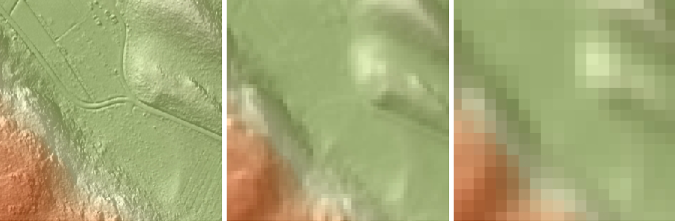
Figure 1. The GRID models with cell size of 1 m (left), 5 m (middle) and 15 m (right).

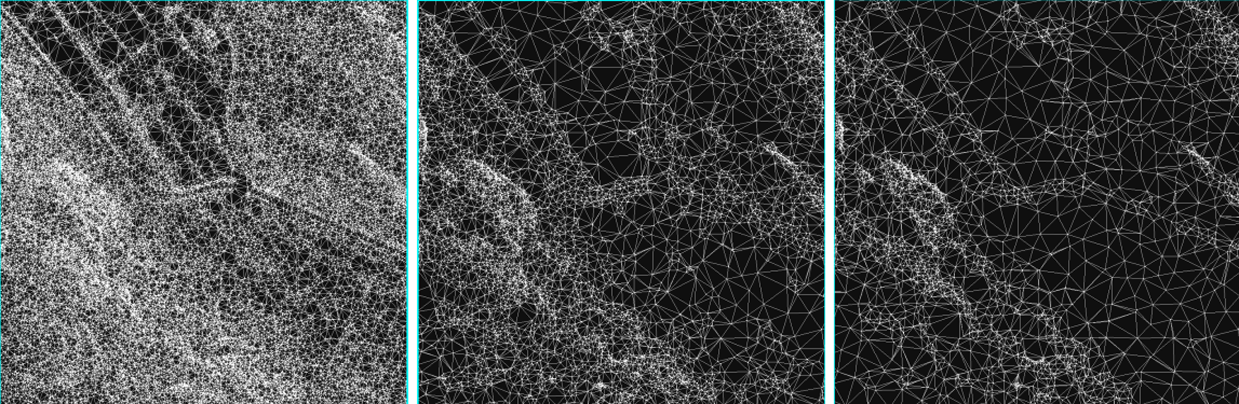
Figure 2. A TIN filtering, the error tolerance of 20 cm (left), 50 cm (middle) and 75 cm (right).

INTERGRATION OF THE TOPOGRAPHIC DATABASE AND THE DEM
The Topographic Database of the National Land Survey of Finland (NLS), which incorporates the most accurate national country-wide positional data on the Finnish topography, was combined with the DEMs. The database comprise the following feature classes: administrative boundaries, transmission networks, rock exposures, mineral soil, relative elevations, transport networks, place names, cultivated areas, man-made structures, bog lands, roads and waters (NLS, 1996).
In the study, selected features from the vector format topographic database were adjusted to the elevation model surface for two purposes: visualization and derivation of height co-ordinates for the 2D features in the topographic database. For the element adjustment ArcGIS offers two choices: a virtual adjustment to the model surface for viewing only, or a permanent modification of vector elements by calculation of height co-ordinates. In order to produce view only maps the first choice was carried out.
An attempt was made to avoid information overload by selecting only key features. For the planned usage purpose, outdoor life and sports, features such as paths and roads were considered important. Settlement in the area is minor consisting mostly of scattered located houses and summer cottages.
The roads that were classified into 6 categories in the original topographic database were selected and separated at different layers. Hiking paths were in one of the categories. For each vector node an elevation was derived from the DEM surface according to the spatial location utilizing the 1 m cell size DEM.

VISUALIZATION EXPERIMENTS AND THE ANALYSIS

Visualization of DEM versus DSM
The aim of this study was to carry out a set of experiments on the visualization of the DEM, suitable for usage on mobile devices. In the first experiment, traditional colours for topographic maps, combined with a hill shading were applied to the elevation visualization (Figure 3, left). In this representation the lakes were in vector format and presented using one colour for all the lakes, even though their surface altitudes vary (Figure 3). However, since the dense laser data also includes measurements from the objects on top of the ground surface an alternative visualization was made. In Figure 3, (right) the elevation was shown by a colour ramp, but the view shading that is overlaid on top of the DEM, has been calculated to the DSM. The DSM was created by obtaining the measurement points within each ground cell, and by giving the highest z co-ordinate of these points as a value of the pixel. The resolution of the model indicated the resolution of the DEM. The applied pixel size in Figure 3 was 1 m.

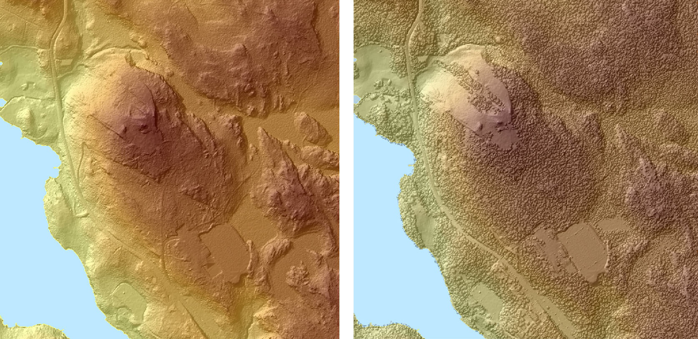
Figure 3. A DEM visualized with the elevation and hill shading (left). A DEM visualized with the elevation and combined with a DSM hill shading (right).

The DEM elevation - DSM hill shading visualization was found to be useful, since the view was not overloaded with information, but a general idea of the landscape was immediately observed. In the Nuuksio area trees and other vegetation strongly dominate the landscape view and these elements are represented by the DSM hill shade experiment. Vegetation is important information for outdoor activities, such as mushroom and berry picking.

Visualizations in different projections
In the second experiment, visualizations with two projections: an orthogonal projection and a camera view (i.e. central projection) were carried out, Figure 4. The traditional map view is in an orthogonal projection.

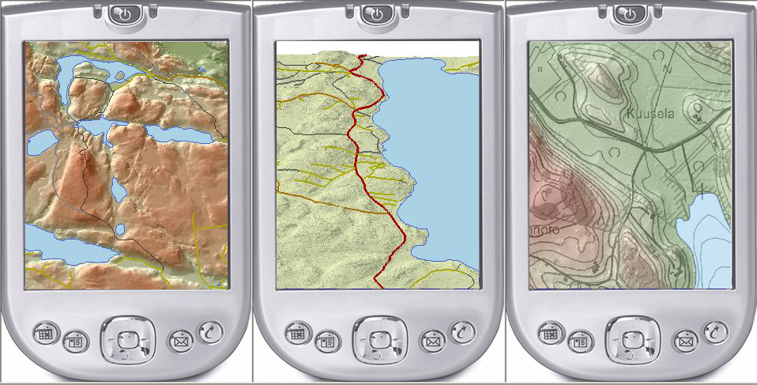
Figure 4. The orthogonal view of the 3D data (left) and (right), and the camera view of the 3D data (middle).

The dominating difference between orthogonal projection and camera view (central projection) is the scale, which is constant in the orthogonal view but changes across the scene in the camera view. Interpretation of the distances and feature sizes is difficult, since the closer the object is to the projection centre, the larger it appears. This problem is emphasized when the shapes in the view do not have structures clear enough to perceive the perspective. The benefit of a camera view is that it simulates what human eye really sees.

DEM scales and vector generalization
In the study, two different DEM data structures were applied — the TIN and the GRID. The GRIDs with 1 m, 5 m, 15 m, 25 m cell sizes were combined to the generalized road database. Three TINs, which were filtered with different thresholds, were created.
Some general advantages of the TIN model versus GRID were discovered in the study; in the TIN model the points are located where there is a major change in the shape of the surface. For example, the points may occur at such locations as the peak of a mountain, the bottom of a valley, or at the edge of cliffs. Even though a TIN model was filtered effectively, the spatially small sized features, such as brooks, remained visible in the model (Figure 2, right). The spatial accuracy of GRID was determined by the cell size that was increased in the study from 1 m to 25 m. The final impact of the cell size to the elevation accuracy is determined by the ground elevation variation. In flat areas the impact is small, but increases along the variation of the ground elevation.
The generalization of roads was carried out with ArcGIS software. After the simplification, the road vectors were smoothed with Bezier curves. Some of the observations were:
- As expected the generalized roads worked well with large cell size GRIDs. With a 1 m GRID a few conflicts were observed: the road base visible in the DEM and the road vector did not match.
- The TIN structure revealed the ground shape accurately when the hill shading was used in the visualization. The triangle edge visualization alone did not give a good 3D shape impression.
- If the edges of triangles were displayed, the overall outlook became overloaded with less filtered TINs.
- The sparse TINs worked well.
- However, the advantage of the GRID is easy integration with other raster databases and its simple structure.

Colours on mobile devices
In experiments 1-3 no attention was paid to whether the colours used would also be suitable for outdoor use. Therefore, in the fourth experiment three different tests were carried out to study the visibility of colours on three different mobile devices: HP iPAQ, Nokia N800 and Nokia N95, Table 1. All devices had screen brightness as an adjustable parameter. The Nokia N95 includes an ambient light detector, which automatically adjusts the screen brightness. During the tests brightness was set to the maximum value in the other two screens, when the devices were tested outdoors.

Mobile device | HP iPAQ | Nokia N800 | Nokia N95
Screen size | 3.5" | 4.1" | 2.6"
Pixels | 240×320 | 800×480 | 240×320
Colours | 65536 | 65536 | 16 million

Table 1. Screen parameters for the tested mobile devices.

Saturation, lightness and contrast
In the test the same map area from the same viewing point and perspective was visualized with different colour settings by increasing the saturation, lightness and contrast in each step by +20 (in Adobe Photoshop). The maps were evaluated indoors and outdoors, during three different weather conditions: sunny, overcast and rainy. Some of the observations are, Table 2:

 | Mobile device | Original | Saturation +20 | Lightness  +20 | Contrast  +20 | Saturation,  contrast +20 | Brightness,  contrast +20
Indoors | HP iPAQ | 3 | 4 | 2 | 4 | 3 | 2
Indoors | Nokia N800 | 4 | 4 | 3 | 4 | 3 | 3
Indoors | Nokia N95 | 4 | 4 | 3 | 4 | 3 | 3
Outdoors   | HP iPAQ | 3 | 3 | 1 | 3 | 3 | 1
 | Nokia N800 | 3 | 3 | 2 | 3 | 3 | 2
 | Nokia N95 | 3 | 3 | 2 | 3 | 3 | 2
Outdoors   | HP iPAQ | 2 | 2 | 1 | 2 | 2 | 1
 | Nokia N800 | 2 | 3 | 1 | 2 | 3 | 1
 | Nokia N95 | 2 | 3 | 1 | 2 | 3 | 1
Outdoors   | HP iPAQ | 1 | 1 | 1 | 2 | 2 | 1
 | Nokia N800 | 1 | 2 | 1 | 2 | 2 | 1
 | Nokia N95 | 1 | 2 | 1 | 2 | 2 | 1

Table 2. Mobile map visibility evaluation, the grades are 1 (poor), 2 (moderate), 3 (good) and 4 (excellent).

- The visualizations, where highly saturated colours with strong contrast were used, functioned well outdoors. However, these colours were found too rich and strong to be used inside.
- Sunny weather with strong outdoor light is a problem for all devices, while rainy and dark conditions are advantageous for the readability of mobile devices’ screens.
- There were minor differences between devices concerning the colours. However, the brightness of the screen is vital concerning readability in sunny conditions. The newest devices were better than the old HP iPAQ.

DEM and shading
The DEM was presented with different colours and combined with the hill shading. The elevation was displayed using one or several colours and using either categorized elevation zones or smooth colour ramp. The main observations were:
- Since absolute elevation values are not important few categories are sufficient to express elevation.
- However, the categorized colours combined with smooth hill shading were visually poor. Both hill shading and elevation should be presented with the same method, Figure 5.
- Hill shading reveals the ground shape.
- The most legible representation was created by using hill shading only, or a DEM with multicolour ramp and hill shading, Figure 6.

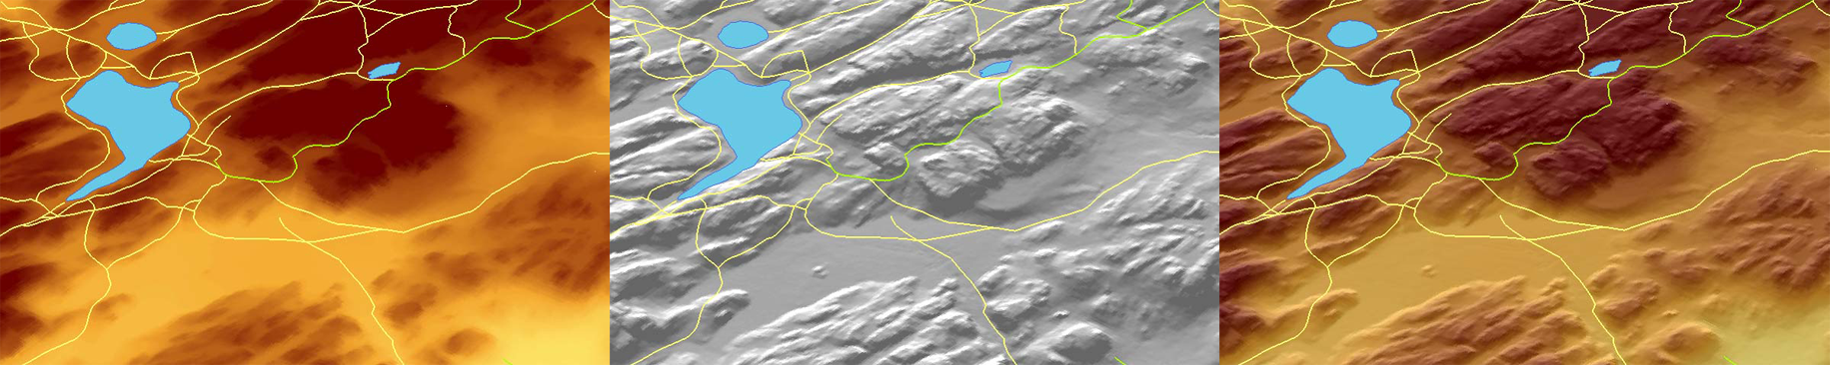
Figure 5. The multi-colour ramp elevation model (left) combined with hill shading (middle) produced the best 3D representation of ground shape (right).

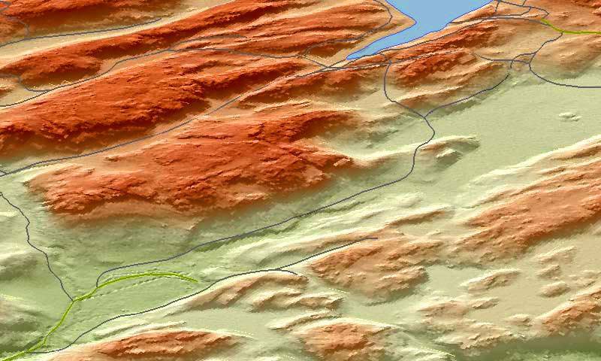
Figure 6. The visualization, where highly saturated colours with strong contrast were used, functioned well outdoors.

Vectors and background
The DEM was combined with the topographic road database and the visualization was carried out using a dark background (DEM) and light colour vectors (roads) - and vice versa. In addition, a traditional map representation with red roads was tested. The representations were evaluated on mobile devices both indoors and outdoors, during three different weather conditions: sunny, overcast and rainy. Some of the observations are:
- Indoors, all visualizations worked well, which means that roads were clearly distinguishable from the background.
- Reading the maps outdoors in sunny weather is challenging. The strong contrast, which was useful in test number one, also helped road vector reading. Both visualizations, (dark background + light vectors and dark vectors + light background) worked if the contrast between background and vectors were strong enough.

CONCLUSIONS
The paper has explored some of the issues on creating and carrying out visualizations of 3D geospatial data combined with vector data from topographic databases for rural areas. The laser scanning data covering the Nuuksio test environment was used extensively in the study. In addition to the DEM, also the DSM derived from the laser data was found to be useful in visualization, since the vegetation dominates the test area landscape. The camera view was used to simulate what human eyes really sees. The visualization experiments for mobile devices revealed some of the related problems and provided directions for further research. The problems were encountered outdoors during sunny weather conditions, but could be compensated by using particular visualization design, such as strong contrast and saturated colours. The most legible representation of the DEM was created by using hill shading only or multicolour ramp and hill shading.
The experiments in the current research were carried out using workstation software. One of our future projects will be to set up web services so that mobile devices can access the data through wireless communication channels.

REFERENCES
Axelsson, P., 2000. DEM generation from laser scanner data using TIN models. The International Archives of the Photogrammetry and Remote Sensing, Amsterdam, Vol. XXXIII, Part B4/1, pp. 110-117.
Frueh, C. and A. Zakhor, 2003. Constructing 3D City Models by Merging Ground-Based and Airborne Views. Proceedings of the 2003 IEEE Computer Society Conference on Computer Vision and Pattern Recognition (CVPR’03).
Gartner, G., Cartwright, W. and M. Peterson (eds.), 2007. Location Based Services and TeleCartography, Lecture Notes in Geoinformation and Cartography, Springer Berlin Heidelberg New York.
Haala N. and C. Brenner, 1999. Virtual City Models from Laser Altimeter and 2D Map Data. Photogrammetric Engineering and Remote Sensing, 65(7): 785- 795.
Meng, L., Zipf, A. and T. Reichenbacher, 2005. Map-Based Mobile Services: Theories, methods and Implementations. Berlin: Springer.
NLS, 1996. Maastotietojen kohdemalli (in Finnish), Topographic database. The National Land Survey of Finland, Publication No. 71. Online: http://www.maanmittauslaitos.fi/Default.asp?id=0&docid=388 (09/05/07).
Sarjakoski, T., Sarjakoski, L. T. and R. Kuittinen, 2007. Establishing a Test Environment for Ubiquitous Geospatial Applications, Proceedings of the 23rd International Cartographic Conference (ICC), August 4-10, Moscow, (in print).
Soininen, A., 2005. TerraScan User’s Guide. TerraSolid Ltd. Online: http://www.terrasolid.fi/system/files/tscan.pdf (31/05/2007).
Wack, R. and H. Stelzl, 2005. Laser DTM generation for South-Tyrol and 3D-visualization. ISPRS WG III/3, III/4, V/3 Workshop "Laser scanning 2005", September 12-14, Enschede, the Netherlands.

